[Insert your Photo here]
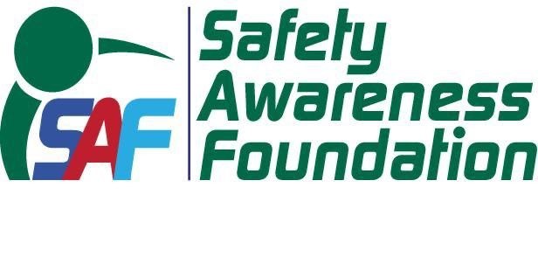

Nonprofit organization
(A Foundation Formed & Registered Under the Act, of 1860)
House # 392, Road # 29, NEW D.O.H.S., Mohakhali, Dhaka-1206. Bangladesh

MEMBERSHIP FORM

I wish to become a member of SAFETY AWARENESS FOUNDATION (SAF) and enclose herewith Tk. 2,000.00
By Cash/Cheque/DD/PO/bKash/Rocket

Name | :
Date of Birth | :
Educational Qualification | :
Membership in other Organization | :
Present Address | :
Telephone Number | :
Mobile Number | :
Email Address | :
Permanent/Office Address | :
NID Number/Passport Number | :
TIN Number | :
Sponsor’s Name & Address | :

Signature of Sponsor:
Approved by Board of SAF
President/General Secretary

Application Date:

Please make √ where you would like to receive the correspondence (Please provide your NID Copy, Picture, TIN Copy)

